
School of Education Administrative Forum
Thursday, September 18, 2014
159 Education Building  9:30 a.m.

AGENDA

- Updates & Announcements
  - BUCKY Award Winner
(Business Office U-Rah-Rah Congratulations & Kudos to You!)
  - Assistant Dean for Human Resources Finalist Presentations

- Gifts & Grants – Beth
  - Core competencies in research administration
  - The Wisconsin Foundation & Alumni Association’s ABE CRM database and Advancement Resources https://www.uwadvancement.org/
- HR and Payroll – Sarah & Christy
  - Missing Unclassified Leave Reports
  - Proposed I-9 Training, October 2014

- Financial Management – Toby
  - Access Online – P-Card Website
https://access.usbank.com

- Facilities – Jesse
  - Space Survey

If there are any topics that you would like us to cover, or if you have suggestions for special guest or training opportunities that you would like to see at future forums, please let us know.

Melissa Amos-Landgraf Associate Dean for Administration (608) 262-4474
Sarah Gomez Rendon Human Resources Assistant Advanced (608) 262-4079
Alexa Kuehl Univ Svcs Prog Assoc, Office Mgmt, (608) 262-6138
HR, Bldg Svcs
Christy Moldenhauer Human Resources Assistant Advanced (608) 262-9149

Toby Schellhase Accountant (608) 262-1765
Beth Walsh Assistant Dean, Gifts, Grants & Contracts (608) 263-5559
Jesse Winters Director of Facilities (608) 445-1878

DID YOU KNOW?
The New Wisconsin Foundation & Alumni Association’s ABE CRM database and Advancement Resources are now available.
https://www.uwadvancement.org

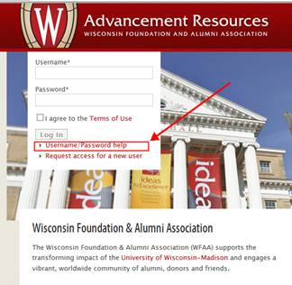

WISER Application Tool/Update
WISER is a new and improved way to view travel and expense data and can be accessed by logging into WISDM. In the future, you will see WISDM reporting options migrate over to the WISER application.
Currently, WISER displays only fully approved and paid expense reports submitted through e-Reimbursement and includes personal, My Corporate Card and University Prepaid payment types. Prepaid items will display in WISER only if the items were entered into the expense report.
WISER Expense reporting is in a pilot phase, so all feedback, issues and suggestions are welcome. Please forward your issues or suggestions to the Madison SFS Team at the SFSMSN@bussvc.wisc.edu email address.
Please go to http://www.bussvc.wisc.edu/acct/sfs/index.html for details on how to access procedures.

