
School of Education Administrative Forum
Thursday, October 17
9:30 a.m. – 11 a.m.
149 Lathrop Hall

Agenda
- SoE Website Update – Barb Smith Simons

HR and Payroll – Gautam, Kurt, Sarah, & teri
- TTC Mapping Information
- FMLA Update
- Direct Deposit Self Service
- COP and Accommodation Process

Next Meeting – Thursday, November 21 – 9:30a.m. – 149 Lathrop Hall

If there are any topics that you would like us to cover, or if you have suggestions for special guests or training opportunities that you would like to see at future forums, please let us know.

SUBMIT A NOMINATION FOR THE BUCKY AWARD! (Business Office Congratulations & Kudos to You!)
- Kristen Hendrickson, Chief Financial Officer, (608) 262-4474
- Kweku Brewoo, Financial Specialist Senior, (608) 890-2514
- Kurt D. Rose, Recruitment & Retention Specialist, (608) 890-1703
- Toby Schellhase, Accountant, (608) 262-1765
- teri engelke, Assistant Dean for Human Resources, (608) 262-6139
- José Escobar, Facilities & Events Manager, (608) 263-3672
- Sarah Gomez Rendon, Human Resources Assistant Advanced, (608) 262-4079
- Lindsey Honeyager, Assistant Dean for Facilities, (608) 263-3697
- Gautam Jayanthi, Human Resources Specialist, (608) 262-9149
- Robert Trettin, Assistant Dean for Financial Management and Research, (608) 890-3898

UW–Madison merits silver rating in first sustainability assessment

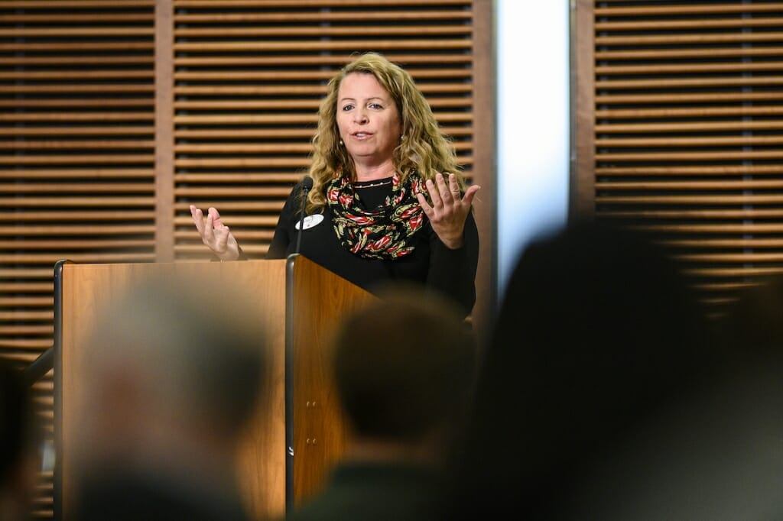

UW–Madison’s first broad sustainability assessment has earned the campus a silver rating for its efforts in resource stewardship, education and research. “People want to be on a campus that cares about the environment,” says Chancellor Rebecca Blank. “It is in the air.”

“Gathering the data for the STARS rating was the easy part. The challenges ahead of us are the hard part,” said Nergard, who is organizing a sustainability council and committees on resiliency and stewardship to help guide the campus in projects to bolster sustainability. “We need a path to get there, a shared direction. We have the intellectual capacity and research potential. We have students who are passionate beyond belief.”

-News.wisc.edu


