

**School of Education Administrative Forum  
October 18, 2018   
9:30 a.m. – 11:00 a.m.  
149 Virginia Harrison Parlor - Lathrop Hall  
1050 University Ave.  
  
Agenda**

**ANNOUNCEMENTS**

* **Partners in Giving**
  + Everyone should have received donation packets, contact Barb Smith Simons ([barb.simons@wisc.edu](mailto:barb.simons@wisc.edu)) with any questions.
* **Compensation Programs**
* **October 19th Pumpkin-Spice-Everything (PSE) day**
  + **Location: Business Office (All Day)**
  + **Feel free to bring PSE treats to share**
* **Our new Facilities and Events Manager – José Escobar**
* **Administrative Functional Areas & Sign-Ups for Training and Review**
  + If you haven’t filled out the Onboarding and Training Survey from last administrative forum please follow the link below:
  + <https://uwmadison.co1.qualtrics.com/jfe/form/SV_8weQYvKt3AL8PTD>

**AGENDA**

**HR and Payroll – Gautam, Sarah, & teri**

* **Recruitment and Retention Specialist update**
* **Additional payroll procedure update**

**Financial Management – Toby & Kweku**

* E-Reimbursement 9.2 update

**Next Meeting – Thursday, November 15 – 9:30a.m. – *159 Education Building***

**If there are any topics that you would like us to cover, or if you have suggestions for special guests or training opportunities that you would like to see at future forums, please let us know.**

[**SUBMIT A NOMINATION FOR THE BUCKY AWARD! (Business Office Congratulations & Kudos to You!)**](mailto:amoslandgraf@wisc.edu)

* Melissa Amos-Landgraf, Associate Dean for Administration, (608) 262-4474
* Kweku Brewoo, Financial Specialist Senior, (608) 890-2514
* teri engelke, Assistant Dean for Human Resources, (608) 262-6139
* Jose Escobar – Facilities & Events Manager, (608) 263-3697
* Sarah Gomez Rendon, Human Resources Assistant Advanced, (608) 262-4079
* Lindsey Honeyager, Assistant Dean for Facilities, (608) 265-2832
* Gautam Jayanthi, Human Resources Specialist, (608) 262-9149
* Toby Schellhase, Accountant - Journey, (608) 262-1765
* Beth Walsh, Assistant Dean - Gifts, Grants & Contracts, (608) 263-5559

<https://www.wisconsin.edu/abe/>

# Welcome to the 2019 Annual Benefits Enrollment website!

[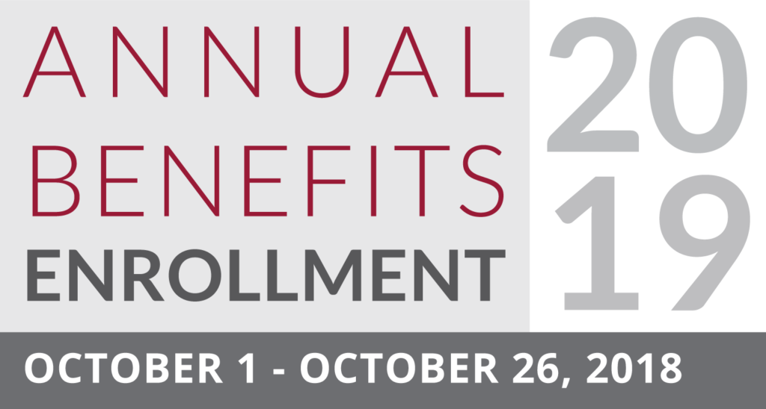](http://my.wisconsin.edu/)

## What is Annual Benefits Enrollment?

The Annual Benefits Enrollment (ABE) period is an opportunity for eligible employees to enroll in or make changes to select benefit plans for the upcoming year.

This is the only time during the year when you are eligible to make benefit plan changes to most plans unless you have a qualifying life event (e.g. family or employment change) that allows you to change your benefits mid-year.

#### **Changes made during this period will be effective January 1, 2019.**

**Important:** This site contains information about benefit opportunities and changes for 2019 only. For information about ***current*** UW System benefits (2018), please visit the [Employee Benefits Website](https://www.wisconsin.edu/ohrwd/benefits/).

###### For a list of benefits fairs, click [here pdf](https://www.wisconsin.edu/abe/download/benefitsfairs.pdf) .