

**School of Education Administrative Forum  
Thursday, February 21  
10 a.m. – 11:30 a.m.  
159 Wisconsin Idea Room  
  
Agenda**

**ANNOUNCEMENTS**

* **Budget Planning Timeline - Melissa**

**AGENDA**

**HR and Payroll – Gautam, Kurt, Sarah, & teri**

* **Insurance Increases**
* **Direct Deposit Measures**
* **Board of Regent Policy Update**
* **Reference Check and P-file Policy Process**
* **Exit Interviews**
* **Workplace Wellness Monthly Series**

**Financial Management – Kweku & Toby**

* **Effort Reporting**
* **P-Card Audit Findings**
* **Fiscal Year Deadlines - Draft**

**Facilities – Lindsey**

* **Weather Hazards**
* **Vilas Flood Updates**
* **Unisex Restroom Locations Across SoE**

**Next Meeting – Thursday, March 21 – 9:30a.m. – *159 Education Building***

**If there are any topics that you would like us to cover, or if you have suggestions for special guests or training opportunities that you would like to see at future forums, please let us know.**

[**SUBMIT A NOMINATION FOR THE BUCKY AWARD! (Business Office Congratulations & Kudos to You!)**](mailto:amoslandgraf@wisc.edu)

* Melissa Amos-Landgraf, Associate Dean for Administration, (608) 262-4474
* Kweku Brewoo, Financial Specialist Senior, (608) 890-2514
* teri engelke, Assistant Dean for Human Resources, (608) 262-6139
* José Escobar, Facilities & Events Manager, (608) 262-6138
* Sarah Gomez Rendon, Human Resources Assistant Advanced, (608) 262-4079
* Lindsey Honeyager, Assistant Dean for Facilities, (608) 265-2832
* Gautam Jayanthi, Human Resources Specialist, (608) 262-9149
* Toby Schellhase, Accountant - Journey, (608) 262-1765
* Kurt D. Rose, Recruitment & Retention Specialist, (608) 890-1703

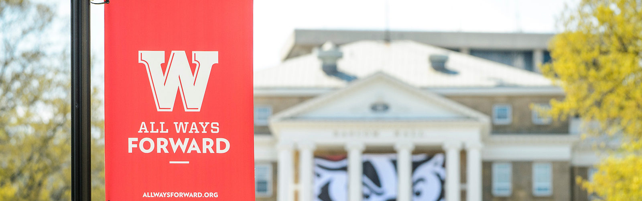

# ADMINISTRATIVE IMPROVEMENT AWARDS

#### NOMINATIONS FOR 2019 AWARDS NOW BEING ACCEPTED

Administrative Improvement Awards recognize outstanding work at UW-Madison in process redesign/development or customer service/delivery that resulted in improved efficiency, increased revenue channels, cost savings or improved service delivery. The award may go to an individual or team.

Nominate a colleague or team of colleagues for this prestigious campus award today! Download the [Nomination Letter Template](https://vc.wiscweb.wisc.edu/wp-content/uploads/sites/245/2019/01/AIA-2019nominationtemplate.docx) and [Nomination Guidelines](https://vc.wiscweb.wisc.edu/wp-content/uploads/sites/245/2019/01/AIA-NominationGuidelines2019.docx) and follow the links below to submit an entry.

**Note:** Nominations are due by Friday, February 22, 2019.

[INDIVIDUAL NOMINATION](https://vc.wiscweb.wisc.edu/administrative-improvement-awards/individual-nomination/)                    [TEAM NOMINATION](https://vc.wiscweb.wisc.edu/administrative-improvement-awards/team-nomination/)

Questions about the Administrative Improvement Awards should be directed to Scott Hildebrand, Office of the Vice Chancellor for Finance and Administration, at 890-3146 or [scott.hildebrand@wisc.edu](mailto:scott.hildebrand@wisc.edu), or Liz Hammen, at 262-9943 or [liz.hammen@wisc.edu](mailto:liz.hammen@wisc.edu), in the Office of the Vice Chancellor for Finance and Administration.