
School of Education Administrative Forum
Thursday, April 18
9:30 a.m. – 11 a.m.
159 Wisconsin Idea Room
Agenda
ANNOUNCEMENTS

AGENDA

HR and Payroll – Gautam, Kurt, Sarah, & teri
- MFA-DUO for students
- Missing Leave Reports/Sick Leave Reduction Notification
- Stay Well Event
- SH/SV reference checks
- Reminders: Benefit prepays & Summer Hires
- Right After Forum – April Workplace Wellness is Yoga at your Desk!

Financial Management – Kweku & Toby
- New Business Services Website – May 30th
- Cost Transfer Tool Property Control Workflow
- Purchase Order Invoice Submissions

Facilities – Lindsey
- Occupant Emergency Plans

Next Meeting – Thursday, May 16 – 9:30a.m. – 159 Education Building

If there are any topics that you would like us to cover, or if you have suggestions for special guests or training opportunities that you would like to see at future forums, please let us know.

SUBMIT A NOMINATION FOR THE BUCKY AWARD! (Business Office Congratulations & Kudos to You!)
- Melissa Amos-Landgraf, Associate Dean for Administration, (608) 262-4474
- Kweku Brewoo, Financial Specialist Senior, (608) 890-2514
- teri engelke, Assistant Dean for Human Resources, (608) 262-6139
- José Escobar, Facilities & Events Manager, (608) 262-6138
- Sarah Gomez Rendon, Human Resources Assistant Advanced, (608) 262-4079
- Lindsey Honeyager, Assistant Dean for Facilities, (608) 265-2832
- Gautam Jayanthi, Human Resources Specialist, (608) 262-9149
- Toby Schellhase, Accountant - Journey, (608) 262-1765
- Kurt D. Rose, Recruitment & Retention Specialist, (608) 890-1703

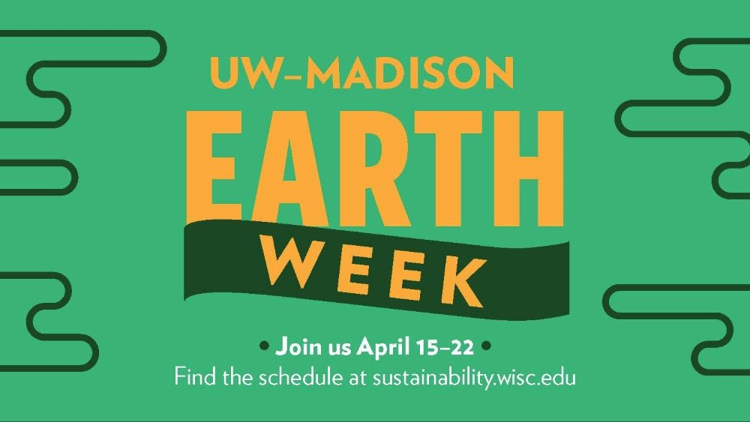

Earth Week is an opportunity to celebrate as well as critically examine our complex human relationships with the natural environment—and with each other. Building on our success in 2018, the Office of Sustainability is hosting a wide range of environment- and sustainability-related events on everything from food waste and bike maintenance to menstruation and environmental justice. We are proud to partner with many campus and community groups and organizations.

